The database spreadsheet is given as *CrystalPools.xlsx* and is collected from the instructor’s Github.

The first thing that was done on the spreadsheet is separating the *First Name* and *Last Name* from the *Sales Person* column. This was done using the *Text to Columns* option under *Data* tab of Excel. The destination option in the *Text to Columns* is the first target column. Since, generally there will be multiple columns being generated from one column while using this option, make sure there are enough empty column to the right of the destination column, else Excel will give a warning prompt saying there are values in the target columns and if we would like to overwrite these columns.

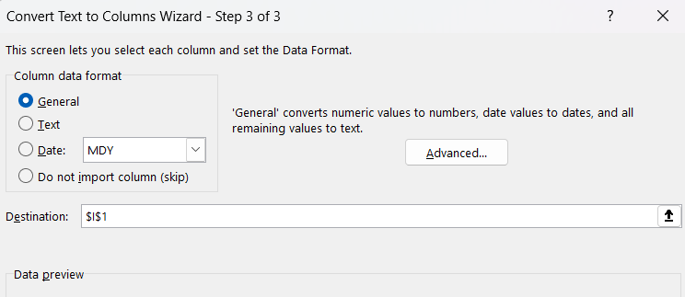

The next thing we learned is using =SUMIF formula. Since, there is no loop options in Excel, it is not possible to apply conditions on sums. Hence, =SUMIF is used in Excel. The condition is given as the second parameter and has to be provided within quotation marks else Excel will give error. I don’t know what the third parameter does, and its clearly optional.

Then the instructor went over sorting and filtering. They can be accessed from *Data* tab. Its very intuitive and there is nothing to be written about it. The only thing that seems significant is that filtering doesn’t modify the actual spreadsheet.

The final thing covered in this project was *Pivot Table*. *Pivot Table* can be used to obtain information from the actual spreadsheet which isn’t directly noted but can be deduced mathematically from the spreadsheet, like sum of figures, counts etc.

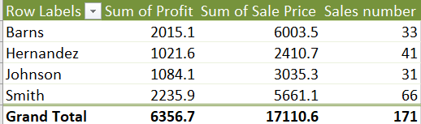

To update the fields in the *Pivot Table*, right click on any value of the *Pivot Table*, and select *Show Field List* and voila.

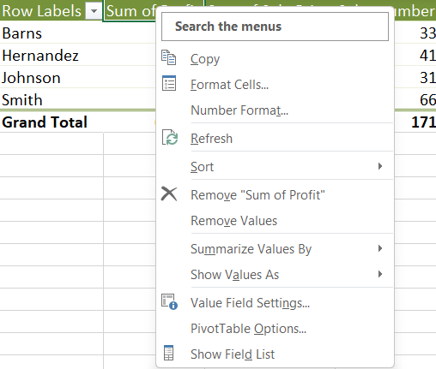

If we insert charts based on *Pivot Tables*, the charts have these additional *Field Buttons* on them.

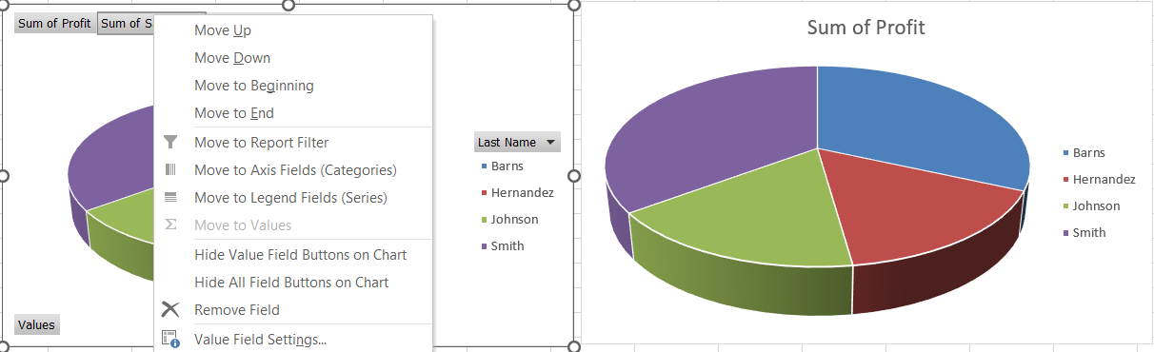

These can be hidden by right clicking on them and selecting *Hide All Field Buttons on Chart* option.

I also learnt a new shortcut in Excel. To select a lot of rows can be tedious. The easiest way is to select the first row of the columns we want to select. Scroll to the bottom or top, works both ways, press shift and click on the last cell, and all the values in between will be selected.